***INTRODUCTION TO HTML/CSS***

1.How are inline and block elements different from each other?

Answer - A block element is an element that will take all the available space whereas the inline element are the element that will take space as much they need. 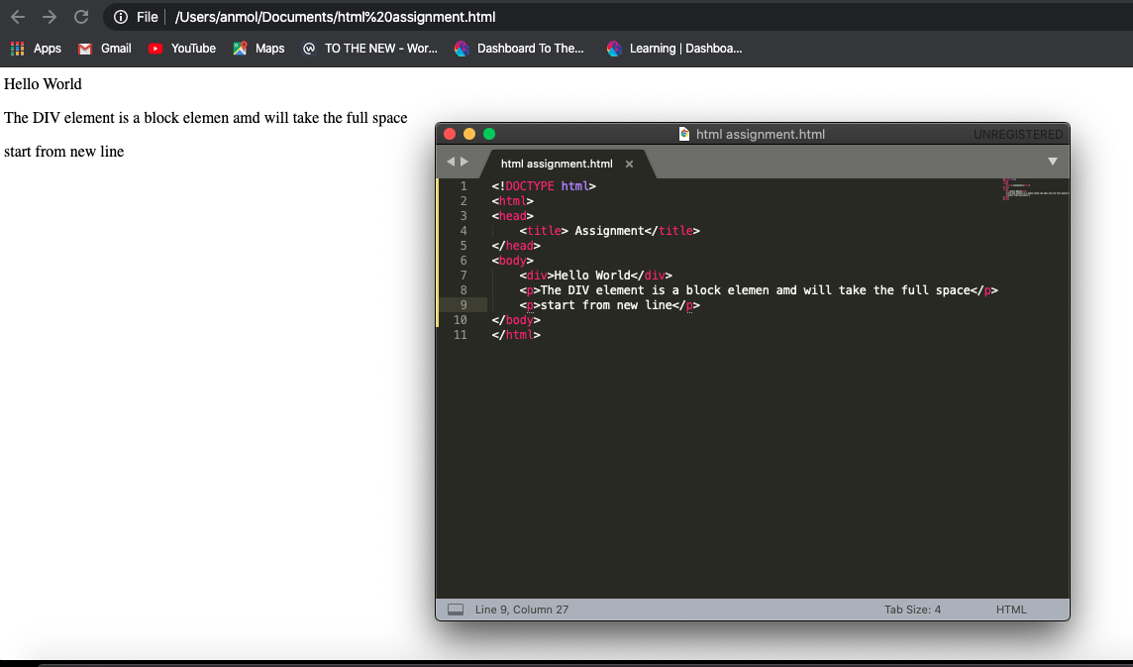

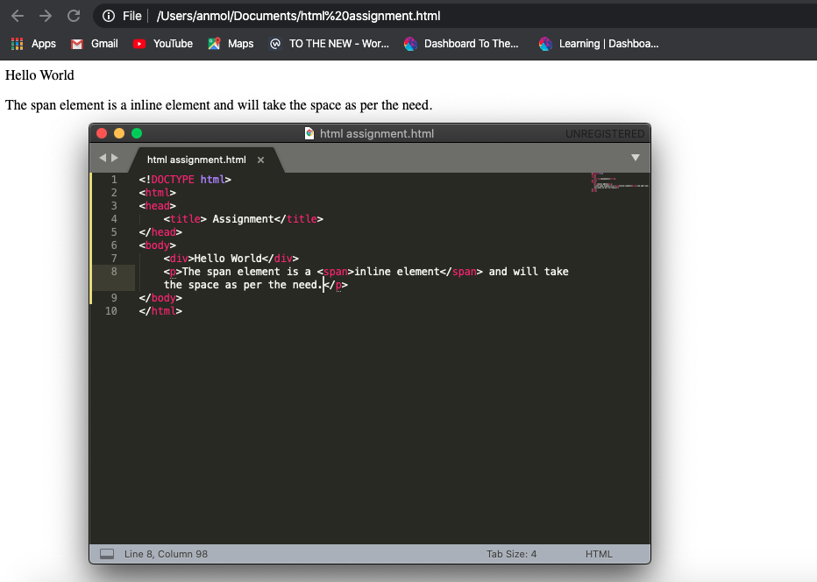

2.Explain the difference between visibility:hidden and display:none

Answer-

The display::none will hide the element and will not allocate any space for it too and the visibility:hidden will also hide the element but it will allocate the space for that element .

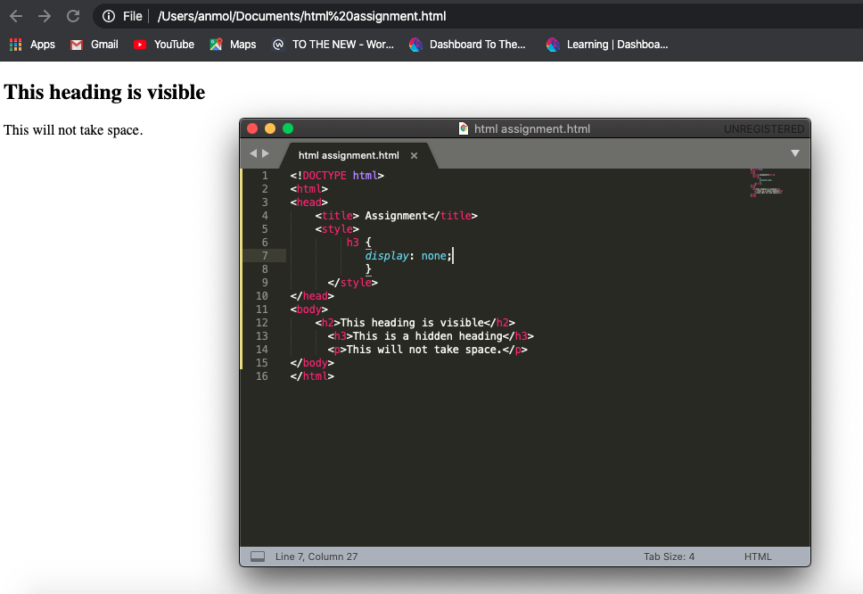

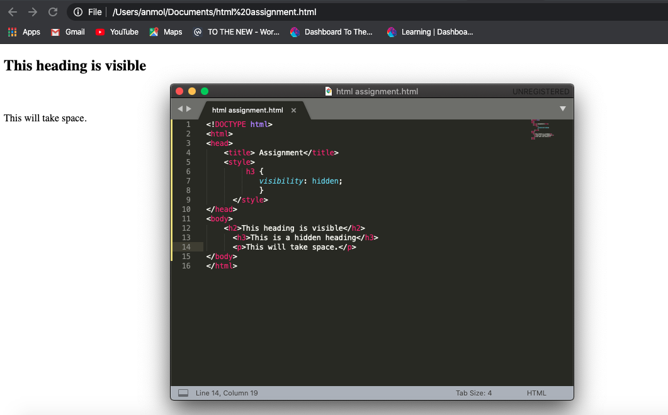

3. Explain the clear and float properties.

The Float Property :

The float property is used for positioning and formatting content and it have 4 value

1. Left : the element float to its left
2. Right : the element float to its right
3. None: the element will show as it is in the text and will not float
4. Inherit: the element inherit the value of its parent.

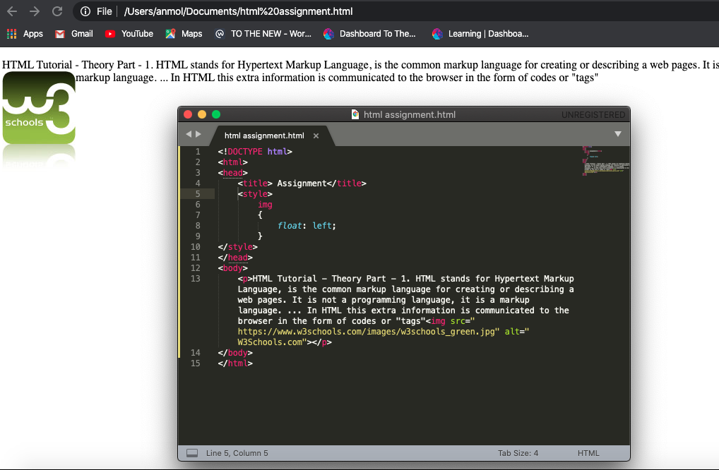

The clear property

1. none - This is by default, and it will allows the element to float on both of the side.
2. left: it will not allow the element to float on the left side.
3. Right: it will not allow the element to float on right side.
4. both: it will not allow the element to float any of the side.
5. inherit - The element inherits the clear value of its parent

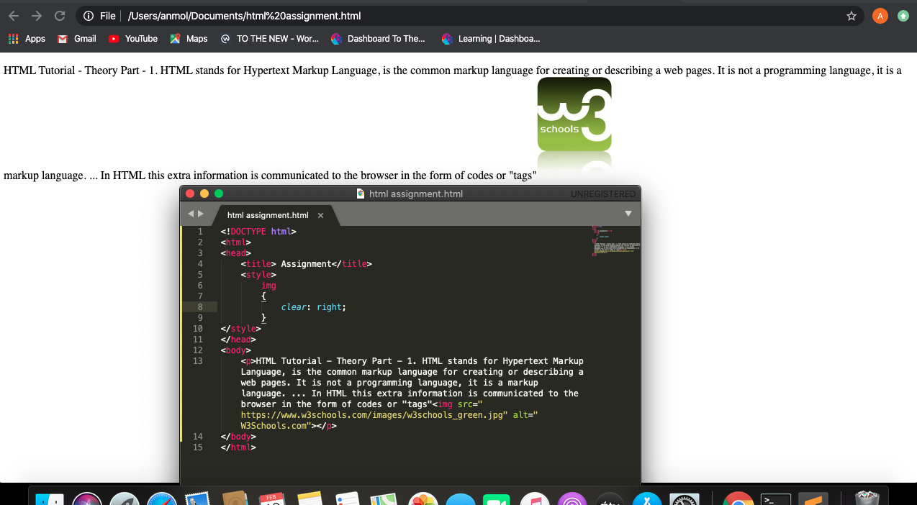

4. Explain difference between absolute, relative,fixed and static.

5. Write the HTML code to create a table in which there are 4 columns( ID , Employee Name, Designation, Department) and at least 6 rows. Also do some styling to it.

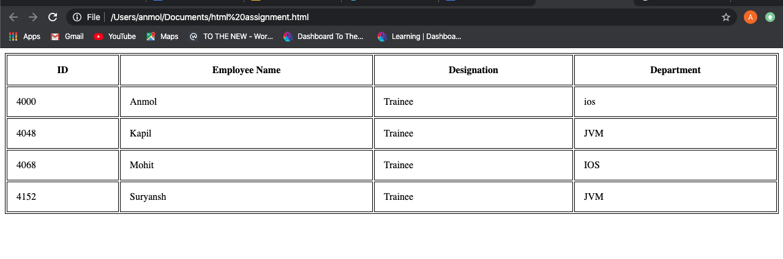

6. Why do we use meta tags?

Answer- Meta elements are typically used to specify page description, keywords, author of the document, last modified, and other metadata.

These element will not display on the page.

<meta> tags always go inside the <head> element.

E.g - <meta name="keywords" content="HTML, CSS, XML, XHTML, JavaScript">

<meta name="description" content="Free Web tutorials on HTML and CSS">

7. Explain box model.

Answer - The CSS box model is essentially a box that wraps around every HTML element. It consists of: margins, borders, padding, and the actual content.

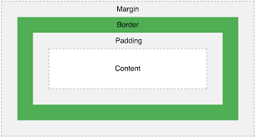

8. What are the different types of CSS Selectors?

Answer- There are different type of selector in CSS

1. CSS ID selector.
2. CSS class selector.
3. CSS Universal selector.
4. CSS Group selector.

**9. Define Doctype.**

Answer - HTML5 doctype does not reference to a DTD. This is because, html5 is a SGML based, unlike HTML4.01. As soon a browser finds <!doctype html> in the starting of an HTML document, it represents the document in standard mode. DOCTYPE keyword is not case sensitive.

10. Explain 5 HTML5 semantic tags.

Answer-

HTML5 tags are-

<header> The <header> element specifies a header for a document or section.

<nav> The <nav> element defines a set of navigation links.

<section> The <section> element defines a section in a document.

<article> The <article> element specifies independent, self-contained content.

<footer> The <footer> element specifies a footer for a document or section.

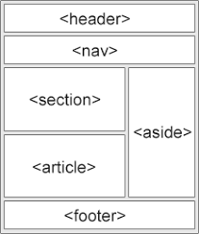

11. Create HTML for web-page.jpg (check resources, highest weightage for answers)

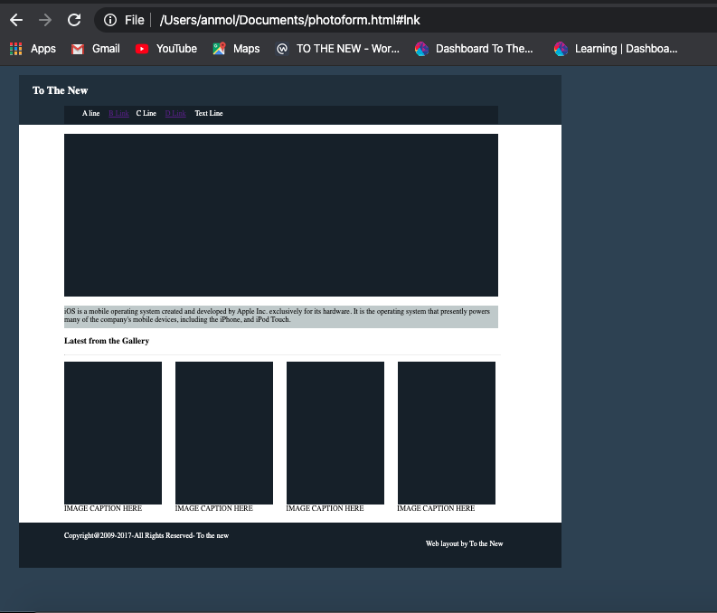

12. Create HTML for form.png (check resources, highest weightage for answers).

